Autoencoders
An autoencoder neural network is another kind of unsupervised machine learning algorithm. Here the number of hidden cells is merely small than that of the input cells. But the number of input cells is equivalent to the number of output cells. An autoencoder network is trained to display the output similar to the fed input to force AEs to find common patterns and generalize the data. The autoencoders are mainly used for the smaller representation of the input. It helps in the reconstruction of the original data from compressed data. This algorithm is comparatively simple as it only necessitates the output identical to the input.
- Encoder: Convert input data in lower dimensions.
- Decoder: Reconstruct the compressed data.
Applications:
- Classification.
- Clustering.
- Feature Compression.
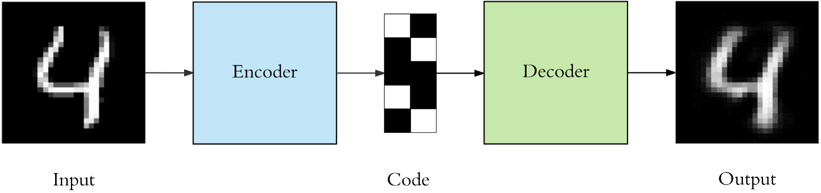

An autoencoder should be able to reconstruct the input data efficiently but by learning the useful properties rather than memorizing it.
To build an autoencoder we need 3 things: an encoding method, decoding method, and a loss function to compare the output with the target.
- Autoencoders are data specific they are able to compress data similar to what they have been trained on.
- Autoencoder for pictures of cats would do poorly in compressing pictures of trees because features it would learn would be cat specific.
- Autoencoders are lossy
This means that the decompressed outputs will be degraded compared to the original inputs (similar to MP3 or JPEG compression).
A few Industrial Applications of Autoencoders.

Image Coloring
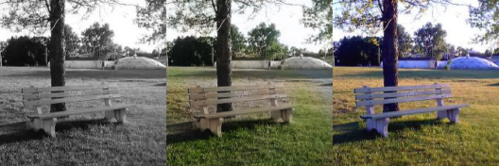
Autoencoders are used for converting any black and white picture into a colored image. Depending on what is in the picture, it is possible to tell what the color should be.

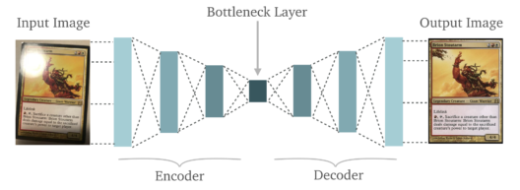
Feature variation
It extracts only the required features of an image and generates the output by removing any noise or unnecessary interruption.

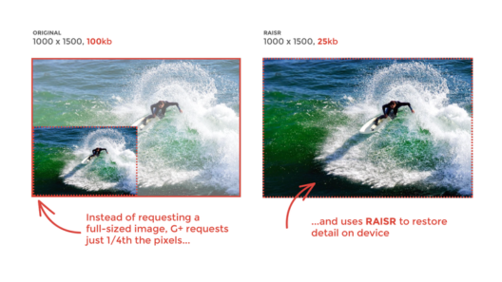
Dimensionality Reduction
The reconstructed image is the same as our input but with reduced dimensions. It helps in providing the similar image with a reduced pixel value.

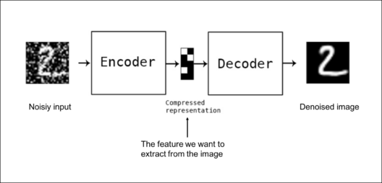
Denoising Image
The input seen by the autoencoder is not the raw input but a stochastically corrupted version. A denoising autoencoder is thus trained to reconstruct the original input from the noisy version.


Watermark Removal
It is also used for removing watermarks from images or to remove any object while filming a video or a movie.

Architecture of Autoencoders
An Autoencoder consist of three layers:
- Encoder
- Code
- Decoder
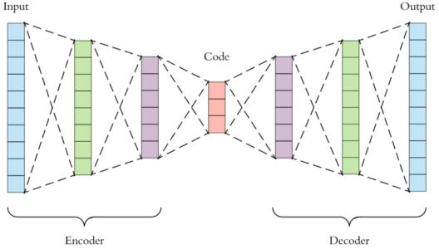
- Encoder: This part of the network compresses the input into a latent space representation. The encoder layer encodes the input image as a compressed representation in a reduced dimension. The compressed image is the distorted version of the original image.
- Code: This part of the network represents the compressed input which is fed to the decoder.
- Decoder: This layer decodes the encoded image back to the original dimension. The decoded image is a lossy reconstruction of the original image and it is reconstructed from the latent space representation.
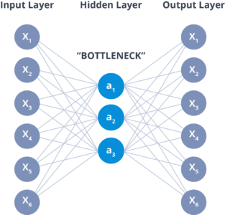

The layer between the encoder and decoder, ie. The code is also known as Bottleneck. This is a well-designed approach to decide which aspects of observed data are relevant information and what aspects can be discarded. It does this by balancing two criteria:
- Compactness of representation, measured as the compressibility.
- It retains some behaviorally relevant variables from the input.
Properties of Autoencoders:
- Data-specific: Autoencoders are only able to compress data similar to what they have been trained on.
- Lossy: The decompressed outputs will be degraded compared to the original inputs.
- Learned automatically from examples: It is easy to train specialized instances of the algorithm that will perform well on a specific type of input.
Hyperparameters of Autoencoders:
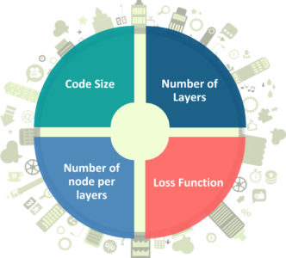
There are 4 hyper parameters that we need to set before training an autoencoder:
- Code size: It represents the number of nodes in the middle layer. Smaller size results in more compression.
- Number of layers: The autoencoder can consist of as many layers as we want.
- Number of nodes per layer: The number of nodes per layer decreases with each subsequent layer of the encoder, and increases back in the decoder. The decoder is symmetric to the encoder in terms of the layer structure.
- Loss function: We either use mean squared error or binary cross-entropy. If the input values are in the range [0, 1] then we typically use cross-entropy, otherwise, we use the mean squared error.
Training autoencoder
1 An autoencoder is a feed-forward non-recurrent neural network. With an input layer, an output layer and one or more hidden layers.
2. It can be trained using the following technique. Compute gradients using backpropagation followed by mini-batch gradient descent.
There are many ways to capture important properties when training an autoencoder.

Undercomplete Autoencoders

- In an autoencoder, when the encoding h has a smaller dimension than x, then it is called an undercomplete autoencoder.

The loss function for the above process can be described as,
L(x, r) =L(x, g (f(x)))
where L is the loss function. This loss function applies when the reconstruction r is dissimilar from the input x.

Regularized Autoencoders

In undercomplete autoencoders, we have the coding dimension to be less than the input dimension.
We also have overcomplete autoencoder in which the coding dimension is the same as the input dimension. But this again raises the issue of the model not learning any useful features and simply copying the input.

One solution to the above problem is the use of regularized autoencoder. When training a regularized autoencoder we need not make it undercomplete. We can choose the coding dimension and the capacity for the encoder and decoder according to the task at hand.
To properly train a regularized autoencoder, we choose loss functions that help the model to learn better and capture all the essential features of the input data.
Two common ways of implementing regularized autoencoders.

2.1 sparse Autoencoders

In sparse autoencoders, we use a loss function as well as an additional penalty for sparsity. Specifically, we can define the loss function as,
L(x, g (f(x))) + Ω(h)
where Ω(h) is the additional sparsity penalty on the code h.

The following is an image showing MNIST digits. The first row shows the original images, and the second row shows the images reconstructed by a sparse autoencoder.
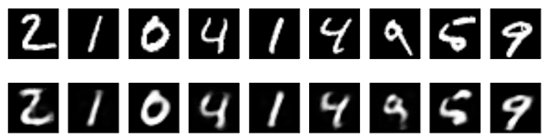
Adding a penalty such as the sparsity penalty helps the autoencoder to capture many of the useful features of data and not simply copy it.

2.2 Denoising Autoencoders
In sparse autoencoders, we have seen how the loss function has an additional penalty for the proper coding of the input data.
But what if we want to achieve similar results without adding the penalty? In that case, we can use something known as denoising autoencoder.

We can change the reconstruction procedure of the decoder to achieve that. Usually the decoder reconstruction procedure as r(h) = g(f(x)) and the loss function as L(x, g (f(x))).

Now, consider adding noise to the input data to make it x~ instead of x. Then the loss function becomes, L(x, g (f(x~)))

The following image shows how denoising autoencoder works. The second row shows the reconstructed images after the decoder has cleared out the noise.
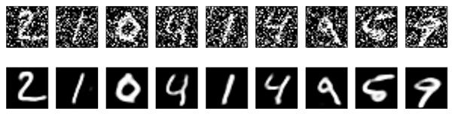
For a proper learning procedure, now the autoencoder will have to minimize the above loss function. And to do that, it first will have to cancel out the noise, and then perform the decoding.

Variational Autoencoders (VAEs)

VAEs are a type of generative model like GANs (Generative Adversarial Networks).
NOTE:
- A generative adversarial network, or GAN, is a deep neural network framework which is able to learn from a set of training data and generate new data with the same characteristics as the training data.
- For example, a generative adversarial network trained on photographs of human faces can generate realistic-looking faces which are entirely fictitious.
- Generative adversarial networks consist of two neural networks, the generator and the discriminator, which compete against each other. The generator is trained to produce fake data, and the discriminator is trained to distinguish the generator’s fake data from real examples. If the generator produces fake data that the discriminator can easily recognize as implausible, such as an image that is clearly not a face, the generator is penalized. Over time, the generator learns to generate more plausible examples.

Like other autoencoders, variational autoencoders also consist of an encoder and a decoder. But here, the decoder is the generator model. Variational autoencoders also carry out the reconstruction process from the latent code space. But in VAEs, the latent coding space is continuous.

